**LAB REPORT OF DATABASE**

Submitted by: Sharifullah Danish

Submitted to: Mr. Basit Ali

1. Write query to generate password for all employees.

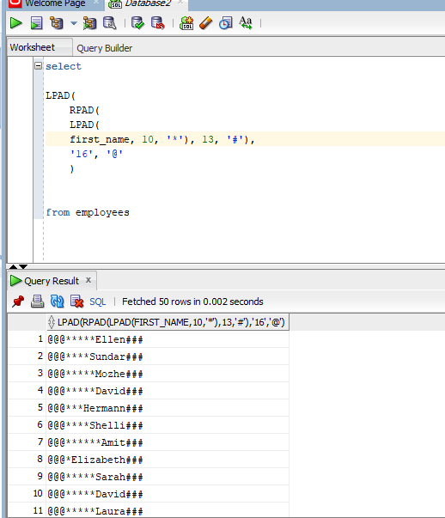

1. Use concat function to display password as:

NOTE: Replace Basit with your name

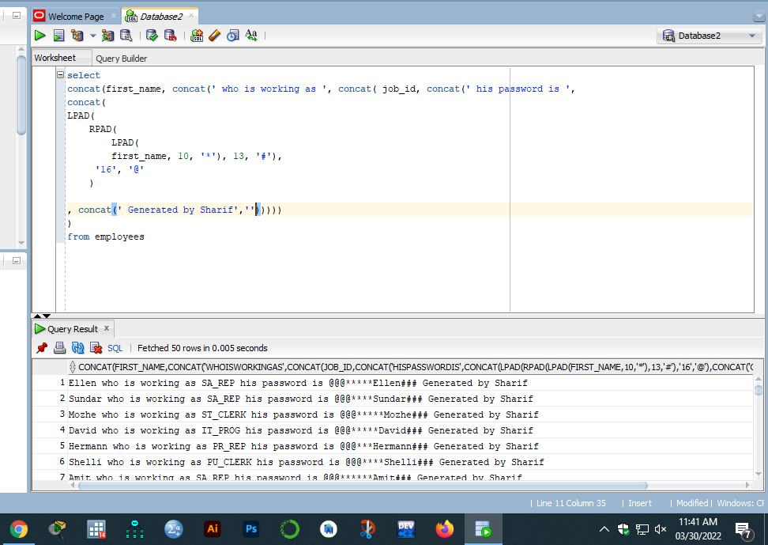

1. Calculate the length of generated password and length of your name as.

NOTE: Replace -- with the actual length of Password and your name

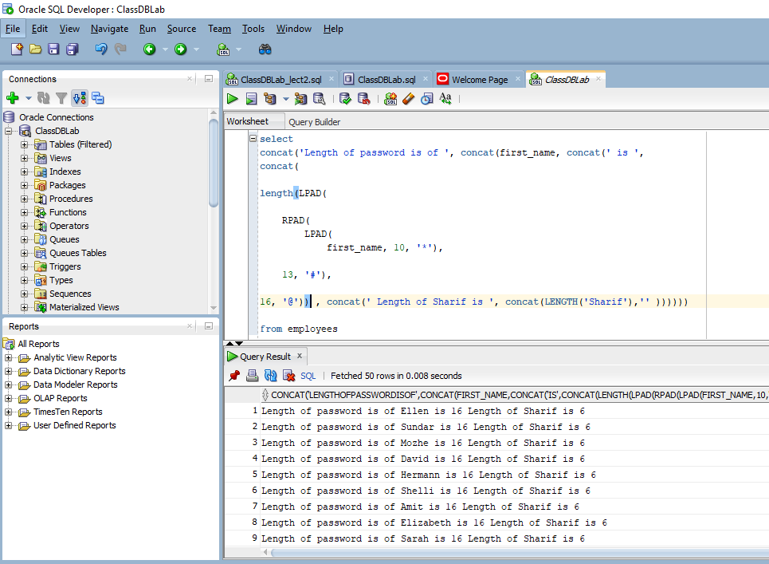

1. Write sql statement to print the following record of all employees whose JOB_ID start with SA.

NOTE: you have to replace SA with SALES in job id

